freETarget
Application Note: Downloading Firmware

SUMMARY
This application note describes the procedure to download new firmware into the signal processing board.

REQUIRED
- Firmware from https://free-e-target.com/downloads/
- freETarget PC software Version 1.12 or higher

INTRODUCTION
The freETarget signal processor is designed to be upgraded using the PC program. Loading new firmware into the board will not damage the board, but may disable certain features until the correct version of software had been returned.

PREPARATION
- Obtain the correct version of firmware from https://free-e-target.com/downloads/ as shown in Figure 1,
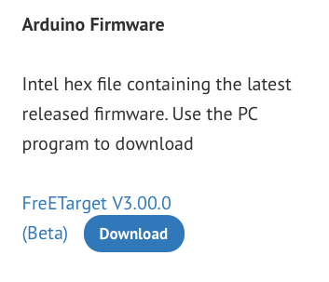
Figure 1: free-e-target.com Download Example
- Save the firmware onto your PC.

INSTRUCTIONS
- Launch the freeETarget program.
  - Verify the version in the lower right corner (Figure 2)
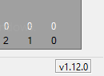
Figure 2: PC Program Version
  - Ensure that the program is NOT connected to the target as shown in Figure 3
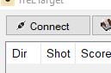
Figure 3: Connection Status
  - If the connection show DISCONNECT, then press this to disconnect the target

- Begin the firmware load process by selecting the download icon as shown in Figure 4.
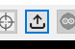
Figure 4: Download Icon

- The Upload Firmware dialog box will appear as illustrated in Figure 5. Example shown from a Mac, your PC will differ
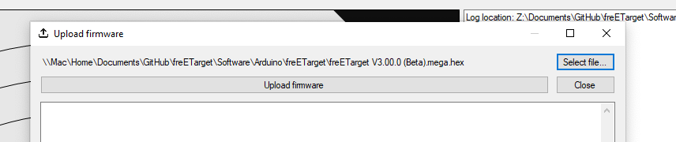
Figure 5: Upload Firmware Dialog Box
- Select the firmware version you saved in the Preparation Section.
- Press Upload Firmware
- Wait for the upload to complete as shown in Figure 6.
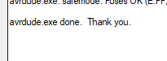
Figure 7: Upload Successful
- Exit out of the firmware download dialog and continue on as a regular shooting session.

TROUBLE SHOOTING
Downloading the wrong firmware to the board or some other issue will not damage the board, however it will prevent it from operating. When this happens:
- Ensure that you have software from the web site, Version 1.12 or higher
- Make sure you have the correct COM port selected in the setup
- Make sure that the target cable is attached correctly
- Make sure that the CONNECT button says CONNECT (not DISCONNECT)
- Verify that the firmware is intended for your version of the board.
- Restart the update process from the start.
- Make sure that you have selected the correct image at the correct location.
- Upload the firmware again.

